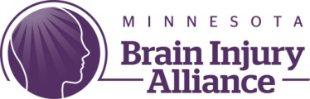
Facebook Live Training
Accomodations While Voting
Amy Zellmer- TBI Survivor, advocate, and author
Mollie Clark – Public Policy Associate at the Minnesota Brain Injury Alliance, Grassroots Lobbyist
Zack Eichten – Public Policy Associate at the Minnesota Brain Injury Alliance, Direct Lobbyist

- What is the ADA?
  - The Americans with Disabilities Act is a civil rights law passed in 1990 and amended in 2008.
  - The ADA covers a wide variety of topics including employment, public services, public services operated by private businesses, telecommunication, and transportation.
  - 2002 the Help America Vote Act was passed to help create more accessible ways to vote, inclusive of non-physical disabilities.

- Accessibility in Polling Places
  - The Government Accountability Office estimates that only 27% of polling places were accessible to people with disabilities in the 2008 elections.
  - There are a number of legally protected rights that people with disabilities are entitled to when voting.
    - Accessible parking and drop-off
    - Accessible routes, including ramps and elevators.
    - Curbside voting if the building is not accessible (often will be offered regardless)
    - When a federal election is taking place there must be at least one accessible voting machine, allowing for privacy and independence.
    - Service animals must be allowed (but not support animals)
    - You are allowed to ask for help filling out your ballot from an election judge OR bring a loved one or caregiver to help you fill out your ballot
    - You can bring notes or even a printed out sample ballot to help you remember who you want to vote for

- What about Invisible Disability?
  - Advocate for yourself! If an election judge is not providing help or the machine is not working report it to the Secretary of State.
  - You do not have to PROVE you have a disability

- Questions?

