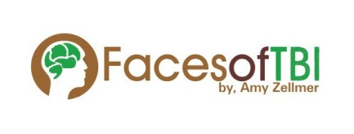
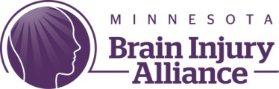
Facebook Live Training
Candidate Research
Amy Zellmer- TBI Survivor, advocate, and author
Mollie Clark – Public Policy Associate at the Minnesota Brain Injury Alliance, Grassroots Lobbyist
Zack Eichten – Public Policy Associate at the Minnesota Brain Injury Alliance, Direct Lobbyist

- Determine what you are looking for in a candidate
  - Leadership Qualities?
  - Issue Positions?
- Determine what issues matter to you
  - Healthcare?
  - Housing?
  - Transportation?
  - Other not related to TBI?
  - Write these into your Planning Grid
- Find the candidates and races on your ballot
  - In MN, go to MNVOTES.ORG
  - For all states got to VOTE411.ORG

- Gather Information on the Candidates’ Positions
  - Candidate Websites
  - Nonpartisan voter information websites
  - Press reports (Newspapers, television, radio)
  - Candidate Speeches and Forums
  - Candidate Questionnaires
  - Candidate Voting Records (while in office)

- Evaluated Candidate Stances
  - Use your Planning Grid to make note of the candidates’ stances
  - Do you agree or disagree with their position? Say nothing?
    - If they say nothing, you can always go to a candidate forum, write a letter or email to the campaign, or simply google “Candidate on Issue” to find if there is more information
- Make your decision
  - Did one candidate stand out?
  - Make sure to vote the way YOU want to vote. Be empowered to vote with you voice, don’t let someone else make your choice for you

