PRESS RELEASE

For Immediate Release CONTACT
Amy Zellmer
AmyZellmerTBI@gmail.com
612-532-8574
www.FacesofTBI.com
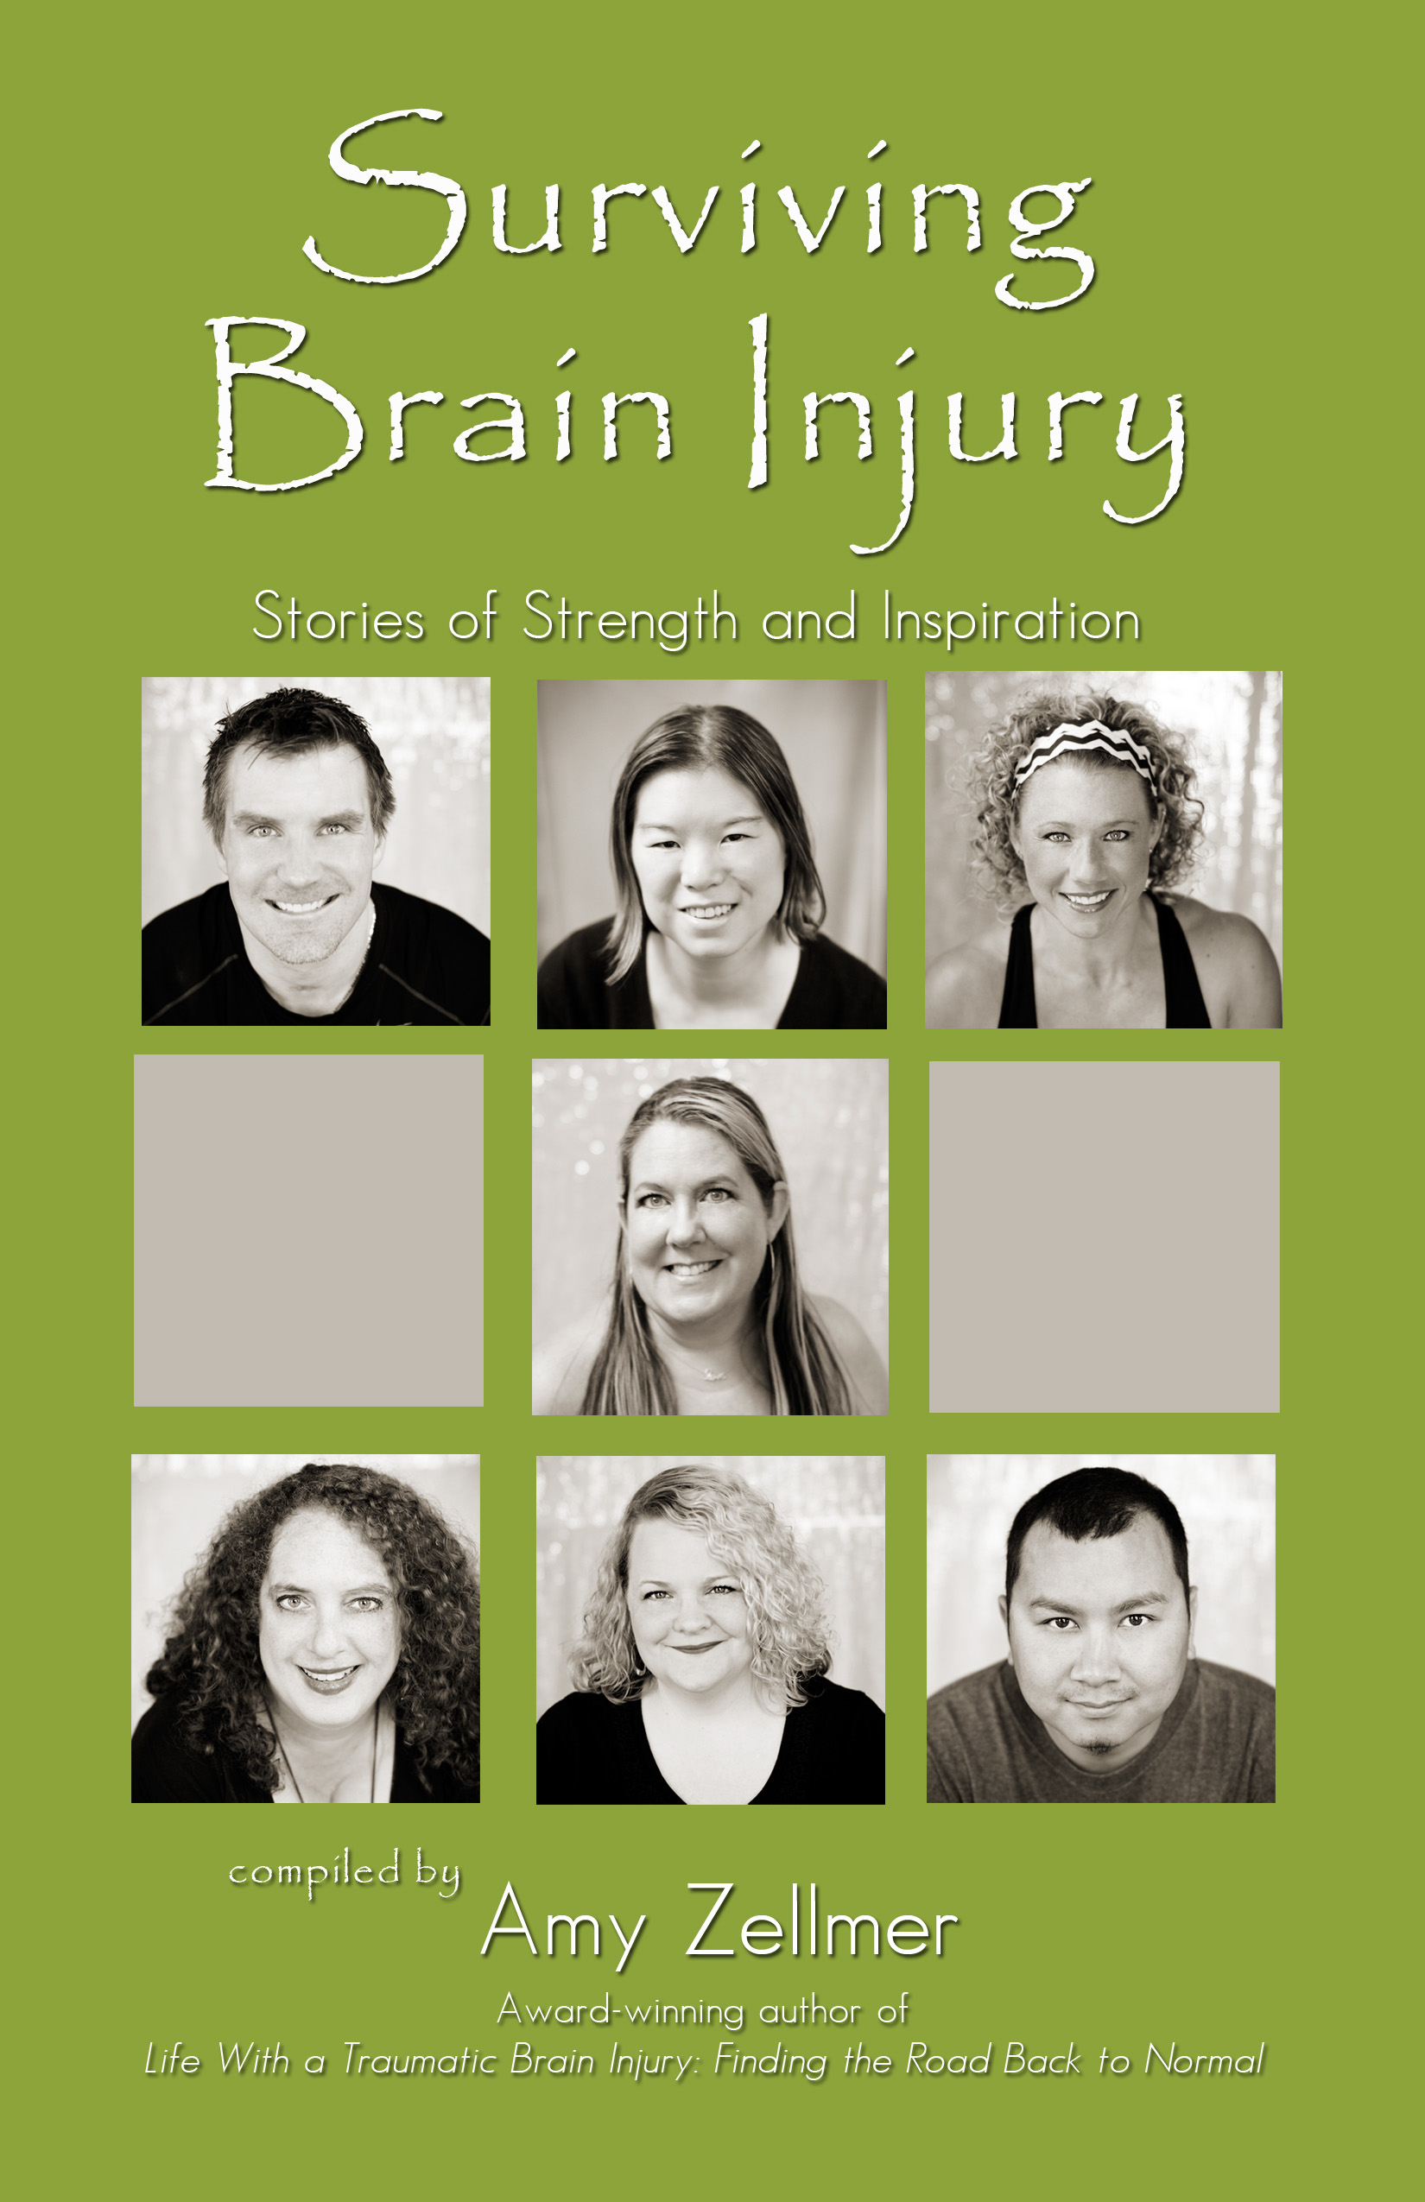
Picture of book cover

“Surviving Brain Injury: Stories of Strength and Inspiration”

Every 13 seconds someone in the United States suffers a Traumatic Brain Injury (TBI).

Saint Paul author, Amy Zellmer, recently launched her second book “Surviving Brain Injury: Stories of Strength and Inspiration.” This book is a collection of short stories written by survivors and caregivers, in an effort to bring awareness to the seriousness of concussions and brain injury.

Every 13 seconds someone in the United States will suffer a TBI. Every single concussion is a brain injury, to some extent. Over 2.5 million people annually will enter the lonely world of TBI, which is often misunderstood, undiagnosed, and overlooked in severity.

Amy hopes to shed new light on this invisible injury that affects over 2.5 million Americans each year. Her new book is a “Chicken Soup” style book of sorts, intended for: 1. Brain injury survivors 2. Caregivers and loved ones 3. Medical professionals.

As you read these contributor’s stories of their journey through life with a brain injury, you will gain an understanding of what it’s like to forget how to use the microwave, or get lost driving to familiar places. You will receive insight into ways to help a loved one who is struggling with a TBI.

In a split second, Amy’s life changed when she slipped on a patch of ice. Brain Injury can happen to anyone, it does not discriminate. Lives are forever changed by a simple fall, car accident, sports injury, or assault. Chances are you or someone you know has been affected by brain injury. This book is a way to help you understand, and not feel alone in your journey.

FACTS:
- Every 13 seconds someone in the United States will suffer a TBI. Every single concussion is a brain injury, to some extent.
- Traumatic Brain Injury (TBI) is the leading cause of death and disability in children and adults from ages one to 44, according to the Brain Trauma Foundation.
- Over 2.5 million people annually will enter the lonely world of TBI, which is often misunderstood, undiagnosed, and overlooked in severity.
- In this past year alone, seven high school boys have died from "seemingly normal" tackles during football games.
- NFL rookies have retired because they felt the risk was too great, while others committed suicide.
- Many TBIs are the result of slip, falls, assaults, and auto accidents.
About the Contributor:
Amy is an award-winning author, speaker, and TBI survivor
living in Saint Paul, MN with her Yorkie, Pixxie.
In 2014 she suffered a Traumatic Brain Injury (TBI), and is presently volunteering and advocating for TBI Awareness around the world. She currently sits on the Brain Injury Association of America's Advisory Council, and she is also involved with the Minnesota Brain Injury Alliance.
Amy has been interviewed on several radio shows across the country, and frequently contributes to the Huffington Post about TBI. She recently created an online community for TBI survivors as well as caregivers and loved ones. Additionally, she produces a podcast series “Faces of TBI” which is available through iTunes.
Amy is available for media interviews.
"Traumatic brain injury causes your world to implode. The effects of TBI are far-reaching and long term; touching every imaginable part of your life, the lives of those you love and those who love you. Amy weaves her own story and the stories of others who have sustained a TBI with important education that provides both help and hope.”
~ Lee Woodruff, New York Times #1 bestselling author and contributor, "CBS This Morning"
“Amy Zellmer is such a passionate voice for traumatic brain injury. She shares her personal story authentically and in a way that moves people to think about prevention. As a guest on my radio show, her openness with responding to questions frankly and her willingness to comfort callers, who shared their own TBI stories, was inspiring. She is a true advocate--with a self-less pursuit to help others and enlighten about this tragic condition. I'd gladly invite her back to my show and recommend her to other media."
~ Roshini Rajkumar ~ Host & Co-Producer, News & Views with Roshini Rajkumar, WCCO (CBS) Radio

